[Applied Computing and Informatics 14 (2018) 166–176](http://dx.doi.org/10.1016/j.aci.2017.07.001)



Contents lists available at [ScienceDirect](http://www.sciencedirect.com/science/journal/22108327)

Applied Computing and Informatics

journal homepage: [www.sciencedirect.com](http://www.sciencedirect.com/)

Classification of fingerprint images with the aid of morphological operation and AGNN classifier



Subba Reddy Borra a,⇑, G. Jagadeeswar Reddy b, E. Sreenivasa Reddy c

a *Department of Computer Science and Engineering, JNTUH, Hyderabad 500085, India*

b *Narayana Engineering College, Nellore, AP 524004, India*

c *University College of Engineering, Acharya Nagarjuna University, AP 522508, India*

a r t i c l e i n f o

*Article history:*

Received 8 May 2017

Revised 12 June 2017

Accepted 13 July 2017

Available online 15 July 2017

a b s t r a c t

The uniqueness, public recognition, firmness, and their least jeopardy of fingerprints made an extensively and proficiently utilized personal authentication metrics. Fingerprint technology is a biometric method that is used to recognize persons on the basis of their physical traits. These physical forms comprise of ridges and valleys prevailing on the surface of fingertips. Fingerprint images are direction-oriented pat- tern fashioned using ridges and valleys. The reputation of the fingerprint image regulates the durability of a fingerprint authentication scheme. For enhancing the restrictions of prevailing fingerprint image aug- mentation approaches we have proposed an effectual method to pact with various fingerprint images. The proposed methodology alienated into three modules. Primarily, the fingerprint image is endangered to denoising procedure where Wave atom transform is used. Once this procedure is accomplished the image augmentation is achieved for improving the classification rate. The morphological operation is used in our proposed technique in order to augment the image. The morphological operators such as dila- tion and area opening are used here for improvement. Finally the ordering of fingerprint image is done. Adaptive Genetic Neural Network (AGNN) is used for classification of images efficiently.

© 2017 The Authors. Production and hosting by Elsevier B.V. on behalf of King Saud University. This is an

open access article under the CC BY-NC-ND license (<http://creativecommons.org/licenses/by-nc-nd/4.0/>).

1. Introduction

In this extremely electronically harmonized society, authentic appreciation is crucial in numerous arenas of life. An entity’s phys- iological and behavioral features, acknowledged as biometrics, are important tools utilized for documentation and authentication [7]. Biometric schemes have been extensively utilized in numerous implementations namely access control, law enforcement schemes and border management schemes to human empathy grounded on biological traits like face, fingerprints, iris, etc. Currently, an exten- sive variability of methods has been established to accomplish the rising demand for safety [8]. In today’s atmosphere of augmented prominence of safety and association, documentation and authen- tication approaches have industrialized into a key technology. Such

* Corresponding author.

*E-mail addresses:* [bvsr79@gmail.com](mailto:bvsr79@gmail.com) (S.R. Borra), [jagsuni@yahoo.com](mailto:jagsuni@yahoo.com) (G. Jagadeeswar Reddy), [esreddy67@gmail.com](mailto:esreddy67@gmail.com) (E. Sreenivasa Reddy).

Peer review under responsibility of King Saud University.

**Production and hosting by Elsevier**

obligation for dependable personal empathy in electronic access control has occasioned in the augmented awareness in biometrics [10].

The uniqueness and perseverance of fingerprint images and its technology, become the most mature biometrics and is extensively implemented to ID confirm scheme. Fingerprint image quality sig- nificantly affects the presentation of fingerprint identification scheme, so it is beneficial and essential for assessing the composed fingerprint images quality in the fingerprint recognition system [1]. Currently, the fingerprint is the most frequently utilized bio- metric identifier in authentication schemes [4]. Natural finger- prints are unevenly characterized into three generic patterns rendering to the complete flow of ridgelines: Arch, Loop, and Whorl. Considering more details like the presence and comparative positions of core and delta in fingerprint images, fingerprint exam- iners further distribute each generic pattern into two or four sub- groups [2].

The uniqueness of finger print identification scheme needs an assessment of his/her fingerprints with all the fingerprints in the database to designate individuals in the storage. Selection of clas- sification method significantly decreases the number of compar- isons throughout fingerprint recovery and therefore decrease the response time of the identification procedure [3]. Fingerprint matching hinge on the comparison measure within some

<http://dx.doi.org/10.1016/j.aci.2017.07.001>

2210-8327/© 2017 The Authors. Production and hosting by Elsevier B.V. on behalf of King Saud University.

This is an open access article under the CC BY-NC-ND license (<http://creativecommons.org/licenses/by-nc-nd/4.0/>).

characteristic features. There are principally two types of features utilized in fingerprint matching: local features and universal fea- tures. Two greatest pertinent local features, known as minutiae, are ridge ending and ridge bifurcation, while universal features are distinctiveness points, specifically core and delta [5]. The minu- tia set is the most extensively utilized fingerprint feature. Current development in fingerprint reconstruction has illustrated that, from the minutia set only, we attain much data about a fingerprint [6]. The procedure of fingerprint documentation is usually done in two stages: a coarse mapping with the help of classification and by filtering the local singularities mapping [9].

The paper is summarized as follows. In Section 2 provides a brief account about the current research work that is performed in the field of face acknowledgment. Section 3 elucidates the pro- posed system of fingerprint image organization by proposed Adap- tive Genetic Neural Network (AGNN). Section 4 provides the results and discussion of our anticipated technique and Section 5 lastly concludes our proposed technique.

1. Related work

Abundant research works are performed in the field of finger- print image organization recently. Some of the current investiga- tions done in the field of fingerprint image organization are defined in this section, fingerprint classification refers to conveying a fingerprint image into a number of pre-specified classes, gives an achievable indexing mechanism. In the area of criminal exploration the mission of classifying fingerprints consumes much time and labor. Frequent attempts have been made to systematize the clas- sification procedure with the help of conventional image process- ing methods but very few have been comprised with the help of law implementation agencies because of their restricted achieve- ments in resolving the issue. The repetition of curiosity in neural networks in current years has wedged the courtesy of those convo- luted in fingerprint recognition as they begin to distinguish the potential recompenses of a neural network method. Ebtesam Najim Abdullah AlShemmary [11] defined a method to fingerprint classification on the basis of both individualities and neural net- work investigation. As noise occurs in many of the fingerprint images comprising those in the NIST databases that are utilized by numerous investigators, it was challenging to acquire the cor- rect number and situation of the singularities like core or delta points that are extensively utilized in current structural classifica- tion methods.

A few transitional solutions on fingerprint organization adopt- ing a neural network as decision stage were given by Patil and Sur- alkar [12]. The neural network was equipped to accomplish matching procedure and was effectively industrialized to recognize and categorize the fingerprint by back propagation algorithm. The investigational solutions presented the technique proposed could progress fingerprint image quality classification accuracy more efficiently than others.

The themes of fingerprint cataloguing, indexing, and reposses- sion have been premeditated broadly in the previous ten years. One issue faced by investigators was that in all publicly accessible fingerprint databases, only some fingerprint sections from each individual are accessible for training and testing, creating it unsuit- able to usage urbane statistical approaches for recognition. C. Leung and C. H. Leung [13] attempted the issue by chief affectedly intensifying the group of training samples with the help of our pro- posed spatial modeling method. With the prolonged training set, they were capable to engage a more urbane classifier like the Bayes classifier for recognition. They implemented the proposed process to the issue of one-to- fingerprint documentation and retrieval.

An algorithm to perceive and remedy skin distortion grounded on a single fingerprint image was presented by Si et al. [14]. Distor- tion recognition was regarded as a two-class classification issue, for that the enumerated ridge orientation map and epoch map of a fin- gerprint are utilized as the feature vector and a SVM classifier was skilled to accomplish the organization mission. Distortion rectifica- tion was observed as a regression issue, where the input was a mis- leading fingerprint and the output was the distortion field. To resolve this issue, a database (known reference database) of numer- ous distorted reference fingerprints and consistent distortion fields was manufactured in the offline stage, and then in the online stage, the adjacent neighbor of the input fingerprint was instituted in the reference database and the consistent distortion field was utilized to transmute the input fingerprint into a usual one.

Raid Al-Nima et al. [15] proposed human authentication method in which Finger Texture (FT) patterns was used to make it efficient. To differentiate the fingers from the hand images, a robust and automatic finger extraction method was used. Enhanced Local Line Binary Pattern (ELLBP) was used to extract new features. The information embedded within the poorly imaged regions of the FTs a method is suggested to salvage missing feature elements. Classification was done by performing Probabilistic Neu- ral Network (PNN).

Al-Nima et al. [16] defined an approach which authenticates based on their finger textures. Finger Texture (FT) features of the four finger images (index, middle, ring and little) are extracted from a low resolution contactless hand image. To enhance the FTs, new Image Feature Enhancement (IFE) was used method to enhance the FTs. The resulting feature image is segmented and a Probabilistic Neural Network (PNN) is employed to classify intelli- gently for recognition.

Fingerprint image improvement was one among the greatest crucial stages in an automated fingerprint identification scheme. Wang et al. [17] defined an operative algorithm for fingerprint image quality enhancement. The algorithm involves of two phases. The primary stage was disintegrating the input fingerprint image into four subbands by implementing two-dimensional discrete wavelet transform. At the secondary phase, the remunerated image was fashioned by adaptively procurement the compensation coef- ficient for each subband on the basis of the mentioned Gaussian template. The proposed algorithm could progress the clarity and continuity of ridge edifices in a fingerprint image.

1. Proposed methodology

Fingerprints are a consistently individual identification biomet- rics because of the singularity, dependability through life, unique- ness among individuals, public acceptance and their minimum risk of intrusion. Because of its uniqueness among people fingerprint authentication is generally acknowledged in all method for efforts to establish safety. Unique fingerprint images are bearing focused example framed by ridges and valleys where the physical patterns comprise of ridges and valleys existing on the surface of fingertips. Fingerprints ridges assume a vital part in the enhancement of fin- gerprints. An effective strategy to manage unique fingerprint images and the enhancement of such images with better quality yield in our proposed work.

In order to enhance the limitations of existing unique finger- print image enhancement methods we proposed an effective method to manage finger impression pictures. The proposed methodology can be classified into three modules. To begin with, the fingerprint image is subjected to denoising process where Wave Atom Transform is used. When this procedure is finished the image enhancement is performed in order to improve the classification rate. The morphological operation is used in our pro-

posed method in order to enhance the image quality. The morpho- logical operators like dilation and area opening are used here for improvement. The last stage of proposed method is the classifica- tion of fingerprint image. Here we have used Adaptive genetic neu- ral system (AGNN) for fingerprint classification (see Fig. 1).

* 1. *Wave atom transform*

The wave Atom Transform is utilized for denoising the images where the images that are to be processed in system have to be fin- ished noise free. To de-noise the image by the Wave Atom Trans- form executes the consequent stages:

Step 1: Apply the right circular movement process to the input image. This is the initial step utilized for noise removal utilizing the wave atom transfer.

Step 2: At the point when the right circular movement is fin- ished, we initiate the forward 2D Wave atom transform.

Step 3: The wave atom coefficients obtained using 2D Wave atom transform is subjected to hard thresholding inorder to improve the image quality

Step 4: Inverse 2D wave atom transform is applied to the above result for refining the process of waveatom transform.

Step 5: The final stage in the denoising process is the applica- tion of left circular shift to the result obtained at the step 4, which completes the denoising process.

Wave molecule changes are utilized with the directional casing to expel noise in finger print images. Once the denoising is done, the following stage in our proposed framework is the image up gradation where we use morphological operation for improving the fingerprint images.

* 1. *Image enhancement using morphological operation*

In the wake of denoising of the images by modifying the con- trast and intensity of the image utilizing waveatom change, mor- phological operation is performed on the image. In morphological operation, the estimation of every pixel in the yield image depends on a correlation of the comparing pixel in the output with its neighbors. By picking the size and shape of the area, we develop a morphological operation that is delicate to particular shapes in the input image. Here two morphological operations, for example, dilation and area opening.

* Dilation:

In dilation, the estimation of the output pixel is the most

extreme estimation of the considerable number of pixels in the

Denoising using Wave atom Transform

input pixel’s neighborhood. In a binary image, if any of the pixels is set to the level 1, the yield pixel is set to 1. It is utilized to build the object in the image. It has the condition,

g*S*(*I*)= {*i*|*Si* ∩ *I*–/} (1)

where *Si* means *S* translated with *i*, *I* is the image and *S* is the struc-

ture element.

* Area opening:

From a binary image the filter that its connected components

with area smaller than a parameter q is called area opening. From a morphological perspective, this filter is an algebraic opening, and it can be extended to grayscale images. In particular, the area open- ing of parameter q of an image *I* is the supremum of the grayscale

images that are smaller than *I* and whose regional maxima are of area greater than or equal to q .It can be defined as:

Let *I* ⊂ *Q* and q ≥ 0. The area of opening of parameter q of *I* is

given by

n *g* (*I*)= {*i* ∈ *I*|*A*(*Hi*(*I*)) ≥ q} (2)

q

Apparently, if (*In*)*n*∈*N* denote the connected components of *N*, n *g* (*I*) is equal to the union of *Nn*’s with area greater than or equal to q:

q

n *g* (*I*)= ∪{*In*|*n* ∈ *N*, *A*(*In*) ≥} (3)

q

By using these morphological operation maximum intensity

pixels of the image alone is selected. Thus, the operation employed contrast and intensity adjusted image is further enhanced by uti- lizing the morphological operation. After morphological operation stage, the final stage is the classification of fingerprint image with the aid of AGNN.

* 1. *Classification using Adaptive Genetic Neural Network (AGNN)*

The Adaptive Genetic Neural Network is used to determine the finger print classification and it is skilled by engaging the features values that are extracted from each and every image. The Adaptive Genetic Neural Network is well skilled by the way of the extracted features. The Adaptive Genetic Neural Network is home-based to three input units, n unseen units and one output unit. The input of the neural network is the feature vector we have abstracted from the images. The network is qualified under a great group of dissimilar fingerprint images to permit them to efficiently catego- rize the exact query image in the testing stage. The neural network works making usage of two stages, one is the training phase and the further is the testing phase.

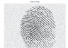

Fingerprint image

Image Enhancement using Morphological Operation

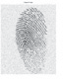

Classified Output

|  |  |  |
| --- | --- | --- |
|  | Classification Using AGNN |  |

Fig. 1. Block diagram for proposed method.

Training phase

In the training stage, the input image is subjected to feature extraction and this feature vector is given as the input to the neural system. Primarily, the nodes are specified with random weights. As the output is previously recognized in the training phase, the out- put attained from the neural network is associated with the origi- nal and weights are diverse so as to decrease the error. This procedure is performed for a great number of images so as to pro- vide a stable scheme having weights allocated in the nodes.

Multilayer feed forward neural network is used in our proce- dure. The structure is portrayed in Fig. 2. The input layer has *N* neurons i.e. number of matrix elements, the unseen layer has *Nsl* neurons and the output layer has *N* neurons i.e. the number of typescripts ranging from A to Z and letters 0–9. Back propagation algorithm is utilized to train the neural network that is designated as follows.

Step 1: Produce arbitrary weights between the interval [0, 1] and dispense it to the hidden layer neurons and also the output layer neurons. Preserve a unity value weight for all neurons of the input layer.

Step 2: Input the training dataset *D* to the classifier and regulate the BP error as trails

*BPE* = *OT* — *ONN* (4)

Eqs. (5) and (6) signifies the activation performance achieved in the output layer and hidden layer correspondingly.

Step 3: Regulate the weights of all neurons as *we* = *we* + D*we*, where, D*we* is the change in weight that can be dogged as

D*we* = r.O2.*B*PE (7)

In Eq. (7), r is the learning rate, frequently it ranges from 0.2 to

0.5.

Step 4: Reprise the procedure from step 2, till BP error gets diminished to a least value. Virtually, the standard to be grati- fied is *B*PE < 0.1.

Testing phase

In the testing stage, the input image is applied to the trained neural network having specific weights in the hubs and the yield is ascertained to classify the images taking into account the trained dataset. In common neural network the procedure will be halted in the wake of testing. In the proposed modified neural network, for testing process we have consolidated the optimization technique inorder to enhance the weight utilized for testing. In our proposed strategy the weights are improved with the assistance of the Genetic algorithm. By integrating optimization procedure the clas-

In Eq. (4), *OT* is the target output and *ONN* is the network output

sification accuracy will be enhanced there by giving improved

recognition of the images. The assembly of the artificial neural net-

that can be dogged as *ONN* = [*o*(1)*o*(2) ... *o*(*M*)]. The network out-

puts can be dogged as

*Mhid*

X

2 2 2

work is demonstrated in Fig. 2.

* + 1. *Weight optimization using genetic algorithms*

*o*(*L*) = *we*2*j*1*O*1(*j*) (5)

2

*j*=1

where,

# 1

With a specific end goal to keep up assortment over the span of optimization process the components are isolated into chromo- somes in the suggested fingerprint classification technique by means of adaptive GA. Till the most incredible solution are got past

*O*1(*j*)= 1 + exp(—*we*

11*r*

· *Oin*

(6)

)

the arrangement of chromosomes this technique is repeated every once in a while. Relocation of individuals among different chromo-

1

w 2N N



1

w11

I1

w211

w212

1

w

C1

12

2

w1N

w21

w22

w21N

H

2

w221

2

I2

w 2N

w

222

C2

H

w22N

|M

w|M|1

w|M|2

w 2NH1

N

I|M|

CN

w|M|N

NH

w

2NH 2

H

Input layer Hidden layer Output layer

Fig. 2. Structure of Artificial Neural Network.

somes raced using the implementation of genetic operators end in the production of fresh individuals. To accomplish the level of vari- ety the rate of migration authorities the algorithm and is sustained privileged the chromosomes.

Step 1: Generation of chromosome

The input for AGA is the random weights which are used for training phase in neural network. The generation of chromo- some for the optimization is the initial phase of GA. Here, ‘*N*’ numbers of chromosomes are generated from the solution space. The initial chromosome are indicated using the below expression,

*C* = [*c*(*n*)*c*(*n*) ... *c*(*n*) ]; 0 6 *n* 6 *Q* — 1, 0 6 *k* 6 *P* — 1 (8)

where *MUPt* is the mutation point, *CL* is chromosome length.

By changing the mutation point actively the mutation is accom- plished adaptive in the recommended method as professed for- mer. With respect to the fitness of the accomplished chromosome, the mutation point is accomplished to alter dynamically. The mutation rate is designated on the basis of the fitness intended. At this time the fitness is on the basis of the errands and dependencies.

The vector that embodies the possible mutation points is pro- vided as follows

*MUPt* = {*mu*1, *mu*2, ... , *muL*}; (12)

At this point L signifies the chromosome length. The mutation

rate will be recognized based on *Fn*.

*i* 0 1

*n*

*Q* —1

*th*

*MUn* = 1; if Fn ≤ *T*

# (13)

where, *c*( ) is the *k* gene of the chromosome, *Q* is the population

*k*

*R* 0; else

pool, *P* is the length of the chromosome.

Step 2: Fitness function

A type of objective function is the Fitness function that is the top target parameter to the optimized value. With the help of the subsequent formula the fitness performance is assessed.

*p*

*Fn* = *wn*/*p* (9)

X

*n*=1

On the basis of the threshold weight values the fitness of every

chromosome is considered here. By picking the result and pro- ceeding to step 5 or moving towards the succeeding step 3 is done after scheming the fitness values.

Step 3: Crossover operation

To attain a latest chromosome termed offspring, the crossover operation is accomplished among two parent chromosomes. The genes are selected and a latest child chromosome is fash- ioned on the basis of the crossover rate *COR*. The fitness function is utilized to the lately fashioned child chromosome after con- structing a new chromosome. The formula for calculating the crossover rate is set as,

*COR* = *Gco* (10)

*CL*

where,

*COR* – Crossover rate

*Gco* – Genes Crossover

*CL* – Chromosome length

The implemented crossover operation make sure that the weights chosen for training the image, are supergenes endure unbroken via the crossover operation that means no liability can be go down out of the scheme or can be swapped. By treat- ment a one-point crossover the crossover operation seams two subsets of duties with their applicable values.

Step 4: Adaptive mutation operation

The recommended technique is based on GA by Adaptive Muta- tion so that the union of the solution is quickened. On the basis

of the mutation rate (*Mr*) the mutation operation is conveyed

out. On the basis of the quantified mutation rate genes are

transformed individually here. The formula for mutation rate is set as,

At this time *T* is intended on the basis of the average responsi- bility value. The mutation is performed in the position consid- ered in Eq. (7). It will be adaptively altered on the basis of the fitness value of every chromosome in iterations.

Step 5: Selection

At the time of the selection process, the *Q* comprehensively pro- duce chromosomes and the *Q* novel chromosomes are situated in a selection pool based on their fitness values. The chromo- somes that encompass good fitness lodge the top positions of the pool in the selection pool. The primary *Q* chromosomes that are at the top of the selection pool are designated for the subse- quent generation among the 2*Q* chromosomes. At this time the selection is grounded on the fitness and implementation time for each task.

1. Results and discussion

The experiment was carried out in MATLAB (2015a) by applying the proposed approach and Image Processing Toolbox was used to produce the improved finger print image. Proposed methodology was validated against FVC2000 dataset. The fingerprint and fake images are collected using the Fingerprint Verification Competition or FVC2000 [18] as well as from the samples that were drawn from SFinGE. Different sensors are applied on FVC2000 to collect almost four databases from this FVC2000 database. As the function of opti- cal sensor is different for every individual, the samples collected are different from each other. Low cost Optical sensor was used to collect images for DB1. Low cost Capacitive Optical sensor was used to collect images for DB2. DB3 is collated using a fairly size- able quality of optical sensors. At last, databases DB4 is syntheti- cally generated using SFinGE. These data base specifications are given in Table 1 and the ample images are shown from Figs. 3–10. Fig. 11 specified below displays the processed output for the input fingerprint images. Dissimilar query fingerprint images are implemented to our proposed scheme and are classified accord-

ingly and is portrayed in the below fig.

As publicized in above figure, the input image is substance to noise reduction and then improved by the morphological operation

Table 1

The four FVC2000 databases.

|  |  |  |
| --- | --- | --- |
| Database names | Sensor type | Image size |
| DB1 | Low-cost optical | 388 × 300 |
| DB2 | Low-cost capacitive optical sensor | 256 × 364 |
| DB3 | Optical sensor | 448 × 478 |
| DB4 | Synthetic generator | 240 × 320 |

*MUR* = *MUPt*

*CL*

# (11)

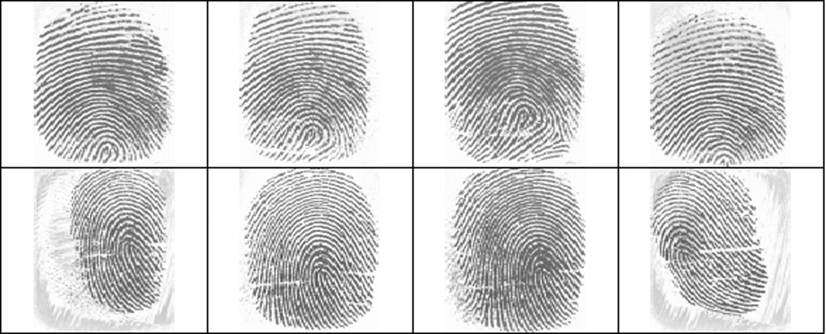

Fig. 3. Sample images from DB1; each row shows different impressions of the same finger.

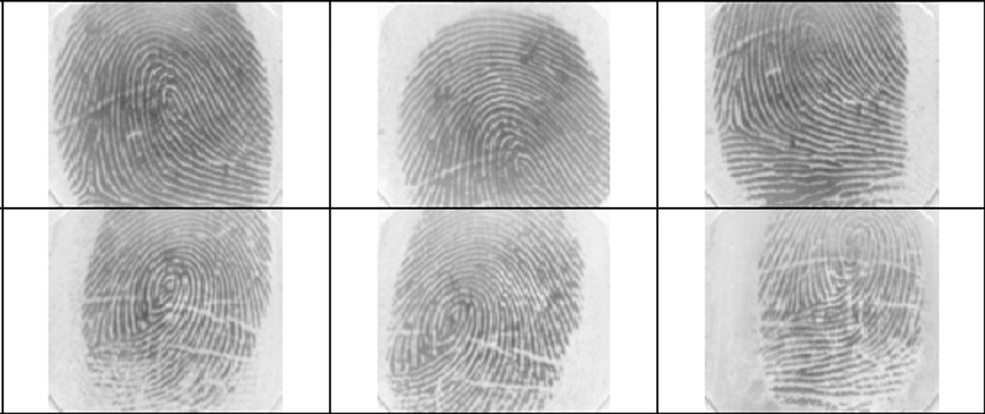

Fig. 4. Images from DB1; all the samples are from different fingers and are ordered by quality (top-left: high quality, bottom-right: low quality).

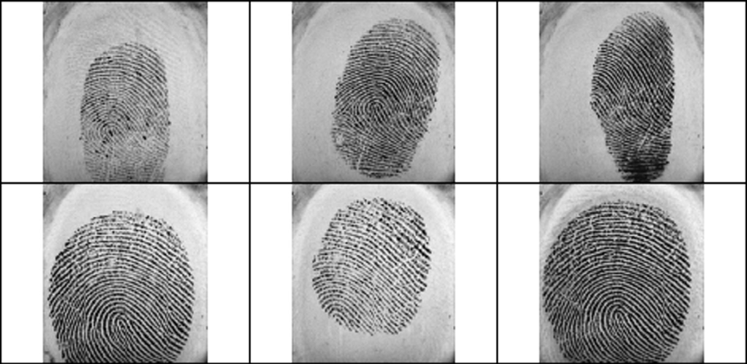

Fig. 5. Sample images from DB2; each row shows different impressions of the same finger.

such as dilation and opening. The improved images are then clas- sified on the basis of the input query image with the help of Adap- tive genetic neural network. The categorized images are then stowed for empathy. The presentations of proposed technique in organization of exact images are then assessed and are associated with that of available neural network.

* 1. *Performance evaluation*

The evaluation metrics like Precision, sensitivity, specificity, accuracy and F-Measure are estimated in order to evaluate the per- formance of the proposed system. These metrics are assessed for different training testing percentages and are tabularized. Similar

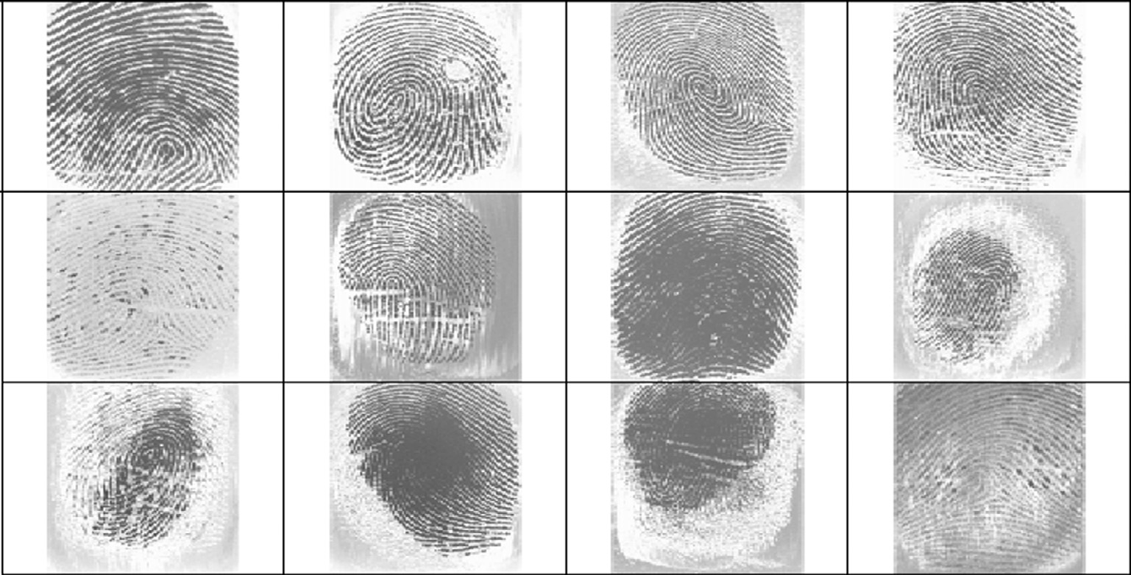

Fig. 6. Images from DB2; all the samples are from different fingers and are ordered by quality (top-left: high quality, bottom-right: low quality).

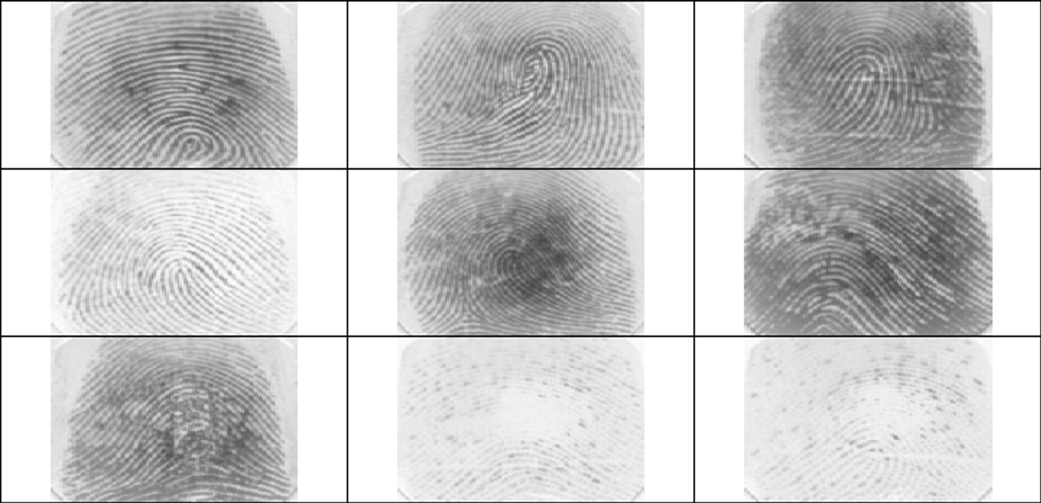

Fig. 7. Sample images from DB3; each row shows different impressions of the same finger.

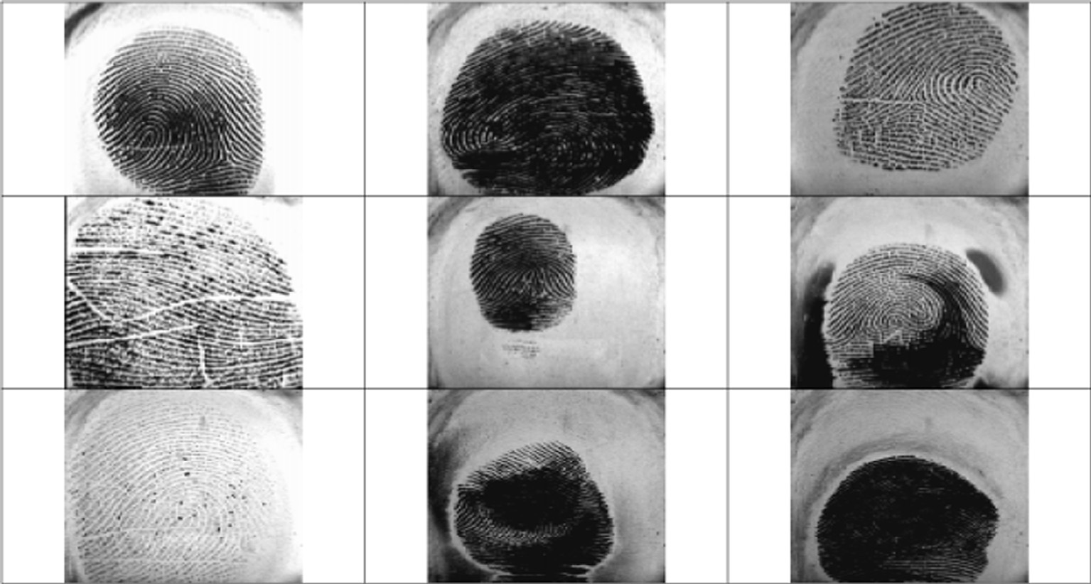

Fig. 8. Images from DB3; all the samples are from different fingers and are ordered by quality (top-left: high quality, bottom-right: low quality).

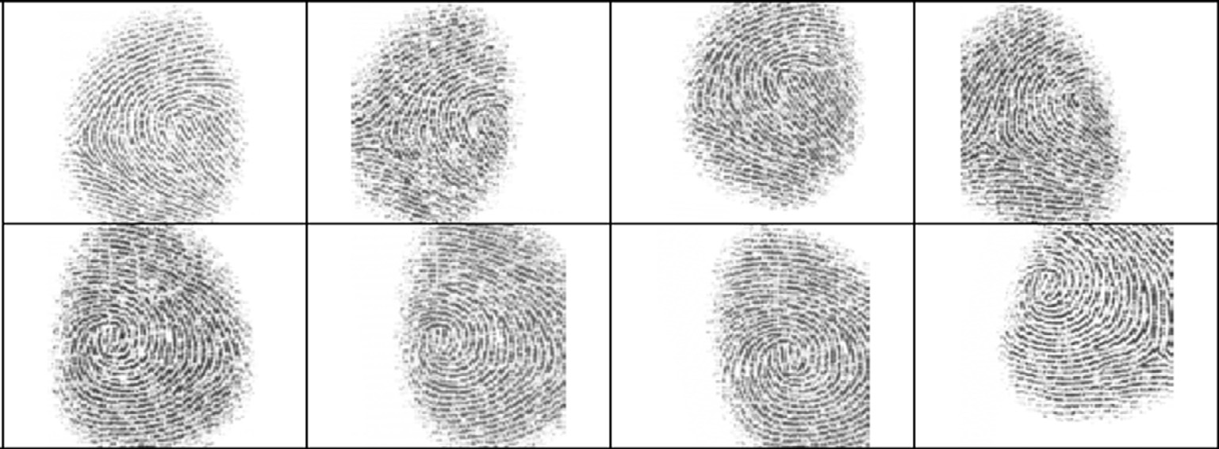

Fig. 9. Sample images from DB4; each row shows different impressions of the same finger.

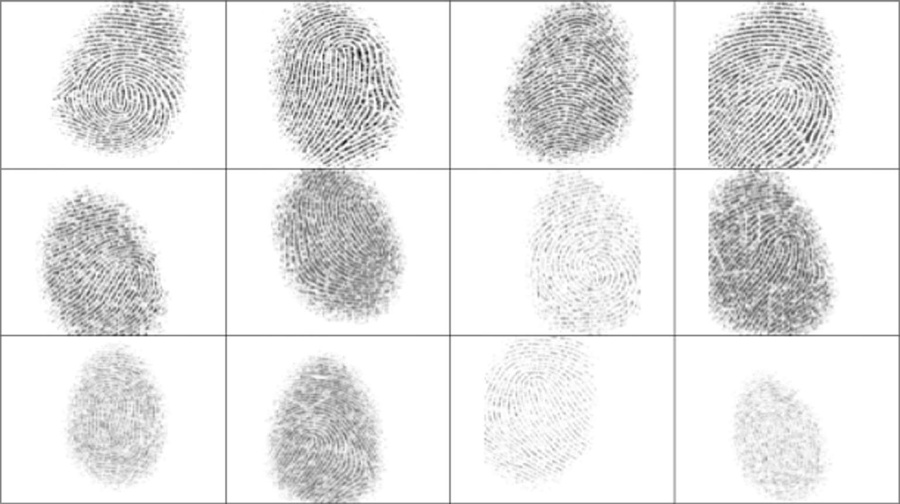

Fig. 10. Images from DB4; all the samples are from different fingers and are ordered by quality (top-left: high quality, bottom-right: low quality).

metrics for the existing methods are also evaluated and tabulated for comparing with proposed method. In our proposed scheme we have utilized neural network which is one of the existing method for classification. The performance metrics are defined in Table 2.

* *Precision* shows the class agreement of the data labels with the positive labels given by the classifier.
* *Sensitivity* shows the effectiveness of a classifier to identify the positive labels.
* *Specificity* shows how effectively a classifier identifies the neg- ative labels.
* *Accuracy* shows the overall effectiveness of a classifier.
* */-measure* shows the relation between data’s positive labels and those given by a classifier.

In [19] the author’s defined non neural network approach for classification of images. Here they defined threshold between the values of the real data and the fake ones for the various non- reference image quality measures (NR-IQM). Afterwards, in the second stage, used the quality scores for a leave-one-out cross val- idation to get an exact assertion about the classification possibility with NR-IQM. To classify data used k-nearest neighbors (kNN) clas- sification. This method allowed testing all possible combinations of

IQM in a simple way. Finally the classification accuracy for discrim- inating real from fake images is calculated.

Tables 3and 4 given below illustrates the performance metrics values such as Precision, sensitivity, specificity, accuracy and F- measure attained by the proposed and NR-IQM with kNN approach for different training and testing percentages. From the values attained it is evident that proposed scheme has outdone the avail- able technique.

Fig. 12 below depicts the graphical illustration of Precision attained for the proposed and prevailing technique. The graph val- idates that the planned scheme displays better Precision when associated with available neural network technique.

Fig. 13 below indicates the graphical illustration of Accuracy attained for the proposed and available technique. The graph vali- dates that the proposed scheme exhibits better Accuracy when weighed against the available neural network technique.

Fig. 14 indicated below presents the graphical view of Sensitiv- ity accomplished for the proposed and existing strategy. The chart confirms that the proposed system shows better Sensitivity when compared with accessible neural network procedure.

Fig. 15 indicated below presents the graphical view of Speci- ficity accomplished for the proposed and existing strategy. The chart confirms that the proposed system shows better Specificity when compared with accessible neural network procedure.

|  |  |  |  |
| --- | --- | --- | --- |
| **S.No** | **Input images** | **Enhanced image** | **Classified Results** |
| 1. |  |  |  |
| 2. |  |  |  |
| 3. |  |  |  |
| 4. |  |  |  |
| 5. |  |  |  |

Fig. 11. Processed output of fingerprint image classification.

Table 2

Performance metrics.

True Positive(tp) The number of images identified as correct, which are actually correct

False Positive(fp) The number of images identified as correct, which are actually out of classification or wrong.

True Negative(tn) The number of images identified as wrong or out of classification, which are actually wrong or out of classification False Negative(fn) The number of images identified as wrong or out of classification, which are actually correct.

Precision *tp*

*tp*+*fp*

Recall/sensitivity *tp*

*tp*+*fn*

Specificity *tn*

+

*tn fp*

Accuracy *tn*+*tp*

*tp*+*tn*+*fp*+*fn*

2 *

F-measure *recall*\**precision*

*recall*+*precision*

Table 3

Performance metric values and comparison between AGNN and NR-kNN approach.

Training –Testing Percentage (%) Proposed Method (AGNN) NR-IQM with kNN algorithm

|  |  |  |  |  |  |  |  |  |  |  |  |  |
| --- | --- | --- | --- | --- | --- | --- | --- | --- | --- | --- | --- | --- |
|  | Precision | Accuracy | Sensitivity | Specificity | F-Measure |  | Precision | Accuracy | Sensitivity | Specificity | F-Measure |  |
| 90–10 | 0.9756 | 0.9781 | 1 | 0.95625 | 0.9375 |  | 0.9638 | 0.9625 | 0.975 | 0.75 | 0.907 |  |
| 80–20 | 0.9652 | 0.9647 | 0.98657 | 0.93879 | 0.9084 |  | 0.9350 | 0.9589 | 0.9247 | 0.75478 | 0.887 |  |
| 70–30 | 0.9453 | 0.9482 | 0.98546 | 0.92587 | 09532 |  | 0.9250 | 0.9307 | 0.92589 | 0.9563 | 0.902 |  |

Table 4

Performance metric values and comparison between AGNN, Neural network and NR-kNN approaches.

Training–Testing Percentage (%) Proposed Method (AGNN) Existing Neural network NR-IQM with kNN algorithm

|  |  |  |  |  |  |  |  |  |  |  |  |  |
| --- | --- | --- | --- | --- | --- | --- | --- | --- | --- | --- | --- | --- |
|  | 90–10 | 80–20 | 70–30 |  | 90–10 | 80–20 | 70–30 |  | 90–10 | 80–20 | 70–30 |  |
| Precision | 0.9756 | 0.9652 | 0.9453 |  | 0.9723 | 0.9525 | 0.9385 |  | 0.9638 | 0.935 | 0.925 |  |
| Accuracy | 0.9781 | 0.9647 | 0.9482 |  | 0.93125 | 0.915896 | 0.907895 |  | 0.9625 | 0.958962 | 0.930789 |  |
| Sensitivity | 1 | 0.98657 | 0.98546 |  | 0.9775 | 0.962479 | 0.97259 |  | 0.955 | 0.92479 | 0.925896 |  |
| Specificity | 0.95625 | 0.93879 | 0.92587 |  | 0.875 | 0.895478 | 0.917856 |  | 0.75 | 0.75478 | 0.9563 |  |
| F-Measure | 0.9375 | 0.9084 | 0.9532 |  | 0.9274 | 0.9045 | 0.9325 |  | 0.9075 | 0.8875 | 0.9025 |  |

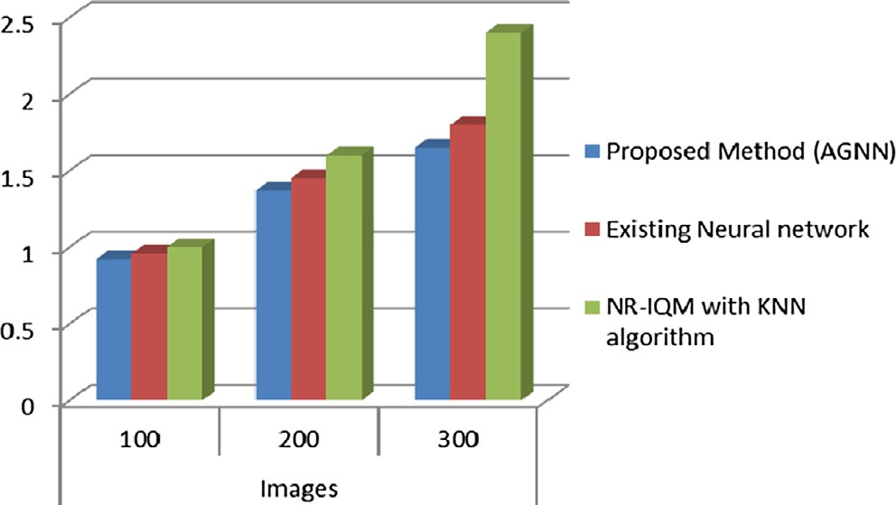 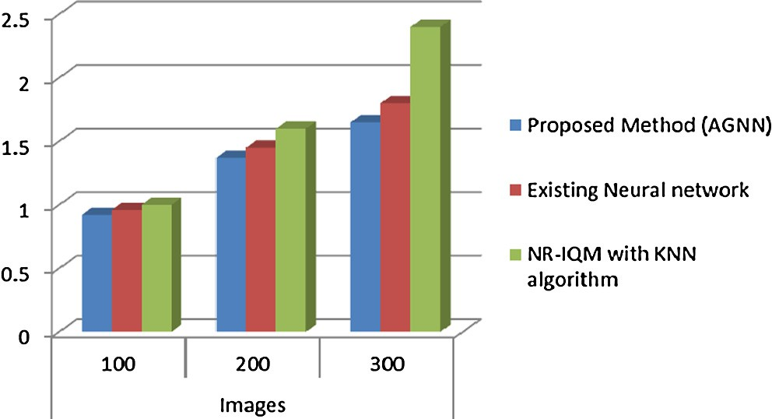

Fig. 12. Graphical representation for Precision attained by proposed and available methods.

Fig. 15. Graphical representation for Specificity obtained using proposed and existing methods.

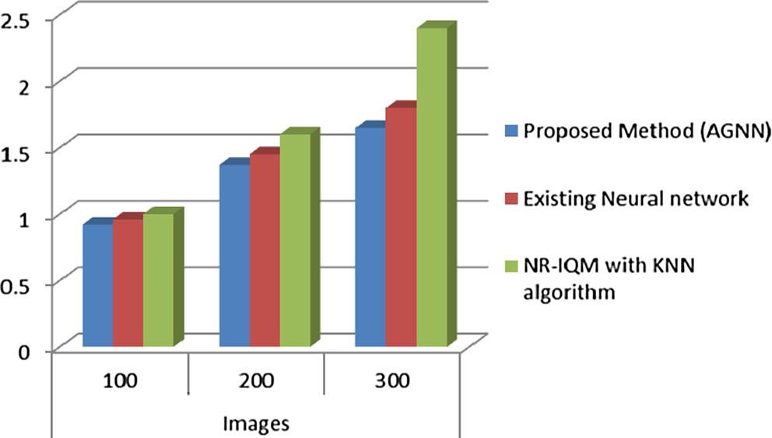 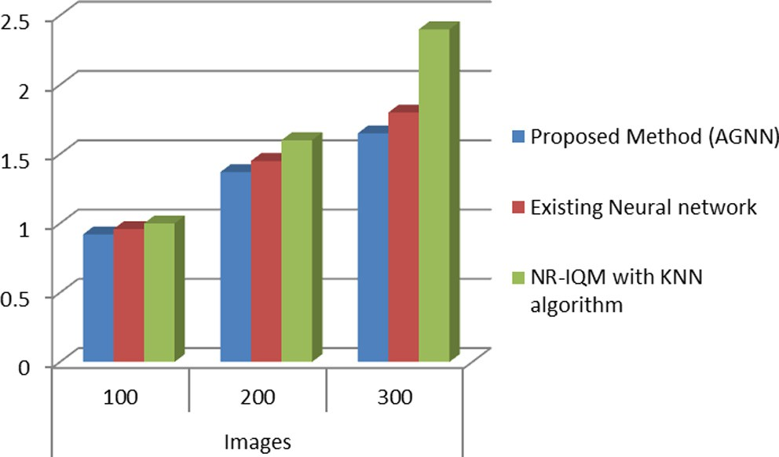

Fig. 13. Graphical representation for Accuracy obtained using proposed and existing methods.

Fig. 16. Graphical representation for F-Measure obtained using proposed and existing methods.

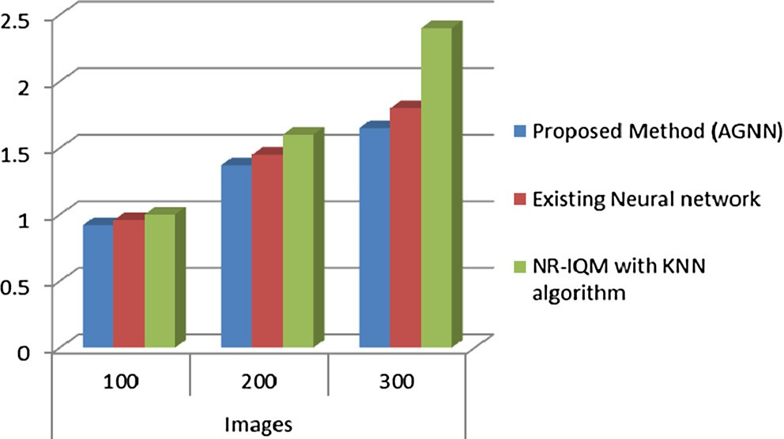

Fig. 14. Graphical representation for Sensitivity obtained using proposed and existing methods.

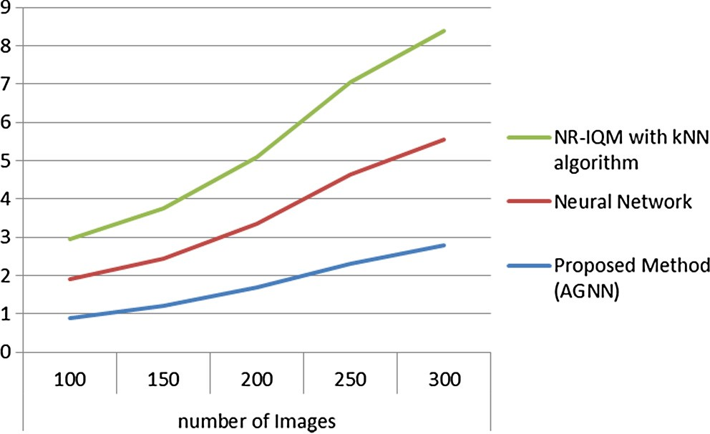Fig. 17. Training time required for the proposed and other methods in msec.

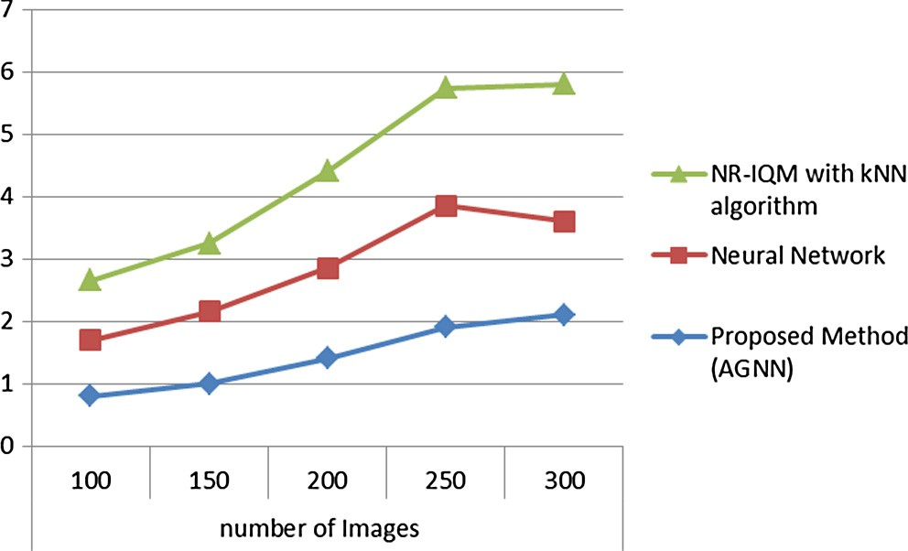

Fig. 18. Testing time required for the proposed and other methods in msec.

Fig. 16 indicated below presents the graphical view of F- Measure accomplished for the proposed and existing strategy. The chart confirms that the proposed system shows better F- Measure when compared with accessible neural network procedure.

The training time and testing time required for the proposed approach AGNN and other neural network approach along with the non neural network approach NR-IQM with kNN are calculated for various image quantities are given Figs. 17 and 18. Although the time required to preprocess and classify the images correct or fake by neural network takes more time than the proposed approach, but the training and testing approaches in proposed approach takes very minimum time and are efficient than other methods.

1. Conclusion

In this work, in order to overcome the disadvantage of various fingerprint images an efficient and productive procedure for unique fingerprint image classification method was proposed. The proposed technique uses Wave atom transform for denoising, morphological operation for image upgradation and Adaptive genetic neural system for image classification. The proposed strat- egy helped in classifying the images precisely in view of the image under question since the images are upgraded and classifier is altered utilizing the enhancement systems. The outcomes acquired demonstrates the adequacy of proposed AGNN based fingerprint classification method as it conveys better parameter values like Precision, sensitivity, specificity, accuracy and F-Measure when contrasted with existing system neural network and non neural network method NR-IQM with kNN approaches.

References

1. Xiu-kun Yang, Yang Luo, A classification method of fingerprint quality based on neural network, in: Proc. of International Conference on Multimedia Technology (ICMT), 2011.
2. Qinghai Gao, Daniel Pinto, Some challenges in forensic fingerprint classification and interpretation, in: Proc. of IEEE Long Island Systems, Applications and Technology Conference (LISAT), 2016.
3. Fadzilah Ahmad, Dzulkifli Mohamad, A review on fingerprint classification techniques, in: Proc. of International Conference on Computer Technology and Development, 2009.
4. [L.F.A. Pereira, H.N.B. Pinheiro, G.D.C. Cavalcanti, Tsang Ing Ren, Spatial surface](http://refhub.elsevier.com/S2210-8327(17)30157-6/h0020) [coarseness analysis: technique for fingerprint spoof detection, Electron. Lett.](http://refhub.elsevier.com/S2210-8327(17)30157-6/h0020) [49 (4) (2013)](http://refhub.elsevier.com/S2210-8327(17)30157-6/h0020).
5. V. Conti, C. Militello, F. Sorbello, S. Vitabile, Introducing pseudo-singularity points for efficient fingerprints classification and recognition, in: Proc. of International Conference on Complex, Intelligent and Software Intensive Systems, 2010.
6. [E. Liu, H. Zhao, L. Pang, K. Cao, J. Liang, J. Tian, Method for fingerprint](http://refhub.elsevier.com/S2210-8327(17)30157-6/h0030) [orientation field reconstruction from minutia template, Electron. Lett. 47 (2)](http://refhub.elsevier.com/S2210-8327(17)30157-6/h0030) [(2011)](http://refhub.elsevier.com/S2210-8327(17)30157-6/h0030).
7. Manish Kumar Saini, J.S. Saini, Shachi Sharma, Moment Based Wavelet Filter Design for Fingerprint Classification, in: Proc. of International Conference on Signal Processing and Communication (ICSC), 2013.
8. V. Sasikala, Dr. V. LakshmiPrabha, A Comparative Study on the Swarm Intelligence Based Feature Selection Approaches for Fake and Real Fingerprint Classification, in: Proc. of International Conference on Soft- Computing and Network Security, 2015.
9. Amina Serir, Farida Bennabes, Fingerprint Classification by Block Ridgelet and SVM, in: Proc. of 10th International Conference on Information Science, Signal Processing and their Applications, 2010.
10. Suchita Tarare, Akhil Anjikar, Hemant Turkar, Fingerprint based gender classification using DWT transform, in: Proc. of International Conference on Computing Communication Control and Automation, 2015.
11. [Ebtesam Najim Abdullah AlShemmary, Classification of fingerprint images](http://refhub.elsevier.com/S2210-8327(17)30157-6/h0055) [using neural networks technique, J. Eng. (JOE) 1 (3) (2012)](http://refhub.elsevier.com/S2210-8327(17)30157-6/h0055).
12. [S.R. Patil (Waghjale), S.R. Suralkar, Fingerprint classification using artificial](http://refhub.elsevier.com/S2210-8327(17)30157-6/h0060) [neural network, Int. J. Emerg. Technol. Adv. Eng. 2 (10) (2012)](http://refhub.elsevier.com/S2210-8327(17)30157-6/h0060).
13. [K.C. Leung, C.H. Leung, Improvement of fingerprint retrieval by a statistical](http://refhub.elsevier.com/S2210-8327(17)30157-6/h0065) [classifier, IEEE Trans. Inform. Forensics Secur. 6 (1) (2011)](http://refhub.elsevier.com/S2210-8327(17)30157-6/h0065).
14. [Xuanbin Si, Jianjiang Feng, Jie Zhou, Yuxuan Luo, Detection and rectification of](http://refhub.elsevier.com/S2210-8327(17)30157-6/h0070) [distorted fingerprints, IEEE Trans. Pattern Anal. Mach. Intel. 37 (3) (2015)](http://refhub.elsevier.com/S2210-8327(17)30157-6/h0070).
15. [Raid Al-Nima, S.S. Dlay, Al-Sumaidaee, W.L. Woo, J.A. Chambers, Robust](http://refhub.elsevier.com/S2210-8327(17)30157-6/h0075) [feature extraction and salvage schemes for finger texture based biometrics, IET](http://refhub.elsevier.com/S2210-8327(17)30157-6/h0075) [Biometrics 6 (2) (2016) 43–52](http://refhub.elsevier.com/S2210-8327(17)30157-6/h0075).
16. R. Al-Nima, S.S. Dlay, W.L. Woo, J.A. Chambers, Human authentication with finger textures based on image feature enhancement, in: Proc. of 2nd IET International Conference on Intelligent Signal Processing (ISP), 2015, London, UK, pp. 1–6.
17. [Jing-Wein Wang, Ngoc Tuyen Le, Chou-Chen Wang, Jiann-Shu Lee, Enhanced](http://refhub.elsevier.com/S2210-8327(17)30157-6/h0085) [ridge structure for improving fingerprint image quality based on a wavelet](http://refhub.elsevier.com/S2210-8327(17)30157-6/h0085) [domain, IEEE Signal Process. Lett. 22 (4) (2015)](http://refhub.elsevier.com/S2210-8327(17)30157-6/h0085).
18. [Dario Maio et al., FVC2000: Fingerprint verification competition, Pattern Anal.](http://refhub.elsevier.com/S2210-8327(17)30157-6/h0090) [Mach. Intel., IEEE Trans. 24 (3) (2002) 402–412](http://refhub.elsevier.com/S2210-8327(17)30157-6/h0090).
19. Amrit Pal Singh Bhogal, Dominik Söllinger, Pauline Trung, Andreas Uhl Non- reference image quality assessment for biometric presentation attack detection, in: 5th International Workshop on Biometrics and Forensics (IWBF), Coventry, United Kingdom, United Kingdom, 2017.